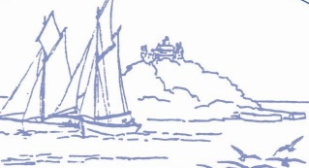
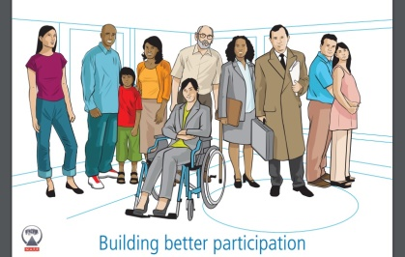
Marazion Surgery
Patient Participation Group

Minutes of the PPG Meeting on 22nd February 2023

1. Minutes of Previous Meeting:

There had been an informal talk on 25th January 2023 with a view to reinstating the Patient Participation Group. This had unfortunately lapsed during the pandemic, though it had been great to see so many previous members attend again.

Mr Ben Mitchell, Engagement officer at the NHS Cornwall and Isles of Scilly Integrated Care Board attended to outline what a PPG was and what they could do to support patients and to support the practice.

Who are we?
- We are a group of patients who work together with staff, so that we can improve our GP practice for everyone.

What do we do?
- Provide feedback about practice services.
- Make suggestions on how patients’ experiences can be improved.
- Promote health and wellbeing information to patients.

How can you contribute?
- Join our meetings.
- Sign-up to our online patients’ group.
- Share your suggestions and ideas with us.

Formal Minutes were not taken as it was an open discussion. A further meeting was arranged for 22nd February, for anyone interested in contributing to the PPG to attend. It was agreed that this would again be an informal meeting with no set Agenda.

2. Welcome and Introduction:

Everyone was welcomed and thanked for attending. It had been agreed that this would be an informal meeting as previously, though Minutes would be taken.

Each person was invited to introduce themselves to the group, this included name, occupation, how long they had been a patient and what they perceived to be the future of the PPG.

3. What next?

They were interested to know about who works at the surgery and what they do. Juliette offered to present this information at the next meeting.

They felt that understanding the appointments system and the different ways in which patients could communicate with the practice would be helpful, both in terms of supporting patients and supporting the practice. Juliette offered to present this information at the next meeting. This would include information about online services, which were due to be increased in the Spring, emails, and use of online consultations.

They were interested to know about how the Practice worked as a business and how it linked with the ICB. Inviting Ben Mitchell from the ICB was suggested for a future meeting.

A fundraising raffle was agreed, to coincide with the King’s Coronation in early May. Juliette would apply to Cornwall Council for the fundraising license. Members would seek raffle prizes from local businesses, and they were happy to help sell raffle tickets. Selling raffle tickets at the front desk and a display of prizes in the waiting room would also help to advertise the PPG to other patients.

In November 2019 there had been an Information Workshop on Dementia and in February 2020 there had been an Information Workshop for Carers. These had proven very popular with patients and been well attended. Prior to the pandemic it had been planned to do more events such as these. It was agreed that a workshop should be planned for the Spring of 2023. Mental health was suggested as a possible topic. Juliette would look into possible speakers with a view to discussing this at the next meeting.

There was a discussion about the use of defibrillators, which were becoming more widely available in community settings. Mr Laity, who was also part of Marazion Town Council, would liaise with Juliette, on behalf of the PPG, to possibly arrange an event on the use of defibrillators and first aid.

Members were keen to support both the patients and the practice. Members offered practical support, such as gardening and odd jobs, which were likely to be gratefully accepted. Some members had been helping with managing the flow of traffic during the previous Covid vaccination clinics and more clinics were likely to be held again soon.

It was important to be fully inclusive and represent all patients, so trying to involve the younger age groups was discussed. The practice had a Facebook presence, and it was suggested that an Instagram account may reach more of the younger age group.

As a group there had previously been Terms of Reference, and these would be brought to the next meeting for review. The ground rules were briefly outlined, including that it was not a forum for individual complaints and single-issue concerns. If anyone had a particular concern, they should be encouraged to contact the practice so that it could be investigated.

Election of Chair was discussed but not voted on; one person was nominated. It was hoped that someone would volunteer to be Chair at the next meeting. Mick offered to be Vice-Chair, a role held previously for the PPG, but did not wish to be Chair. It was agreed that Juliette would be the link for communications with the practice and would also provide administrative support; she should not therefore be Chair.

4. Date of next meeting:

The next meeting would be held on Wednesday 22nd March at 6pm.

There was a small meeting room upstairs but as this was also a working office, PPG meetings could not be held there in working hours. Everyone was happy to meet in the waiting room area and Wednesday evenings were the most popular with those in attendance, though this could be reviewed.

The Practice offered evening clinics on alternate Tuesdays and Wednesdays; holding a meeting on the same night as these clinics was to be avoided as the waiting room would be needed for patients who were unwell.

Action List:

Presentation on Practice staff and how patients can access services (next meeting) | JCB
Invite Ben Mitchell to a future meeting | JCB
Raffle prizes | Everyone
Raffle license and printing of tickets | JCB
Potential speaker for future workshop | JCB
Defibrillator and first aid – linked with Marazion Town Council | Derek Laity
Promote PPG membership in community | Everyone
Consider Instagram presence | JCB

